1. System notification (email) to admin on new safepass application – whenever there is a new application submitted, the system should send out a notification email to the admin.. so the admin knows there is a new SafePass application and requires processing.
2. When the applicant is filling up the application form, the column for “Position / Title” is to be made Mandatory.

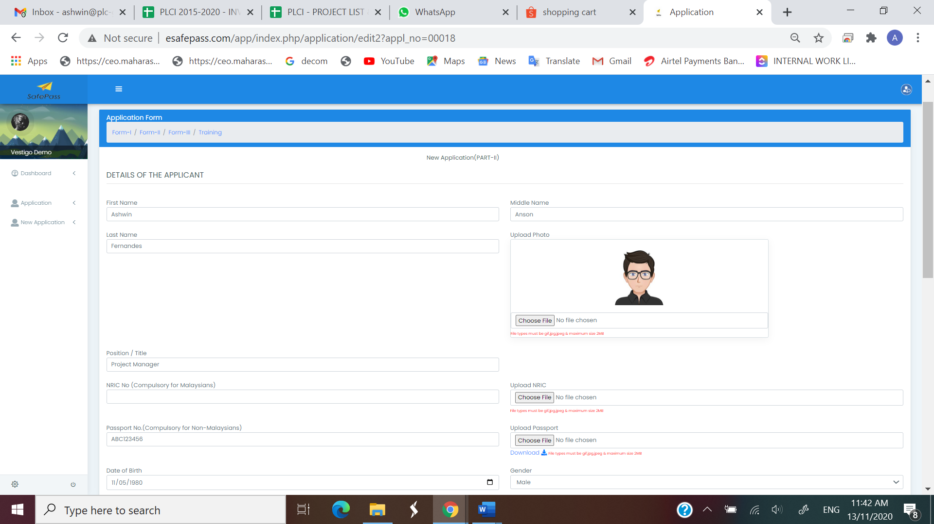



1. When “Nationality” is selected as “Malaysian”, “NRIC Column (compulsory for Malaysians) is to be made mandatory. When “Nationality” is selected as other than “Malaysian” (any other nationality), then the “Passport No” field should be made mandatory.

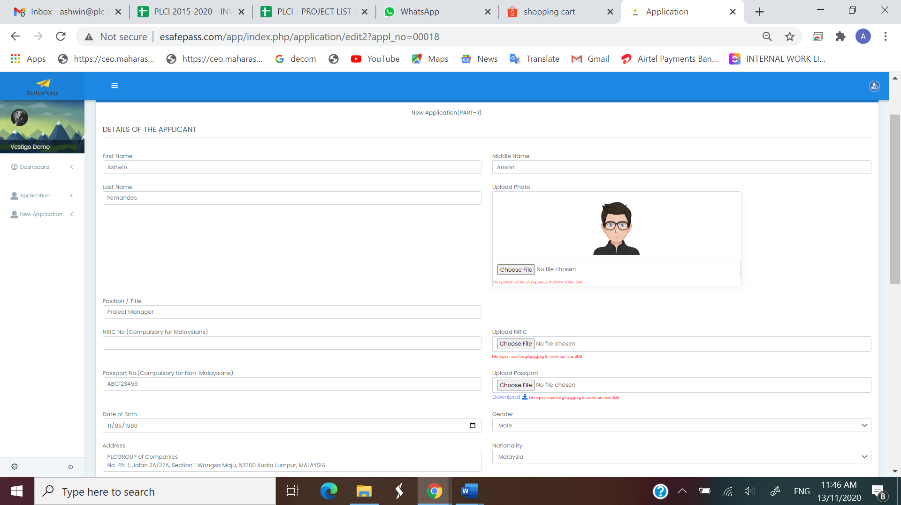



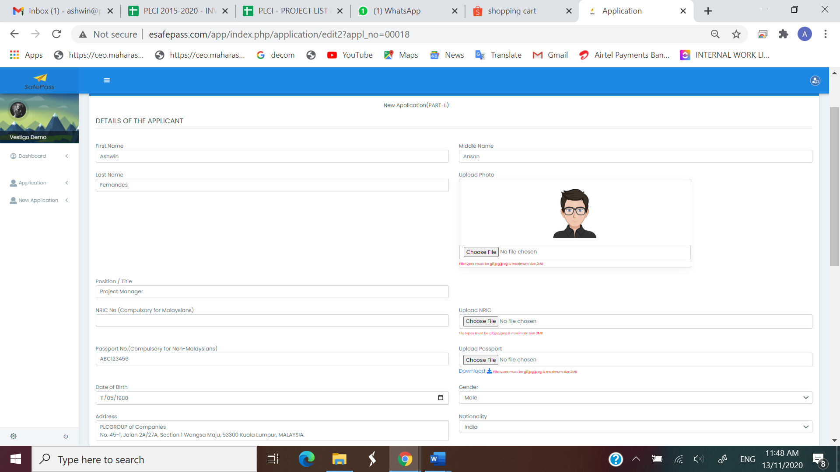



1. The format of the field “NRIC” is to be standardised to the following format throughout the form:

xxxxxx-xx-xxxx

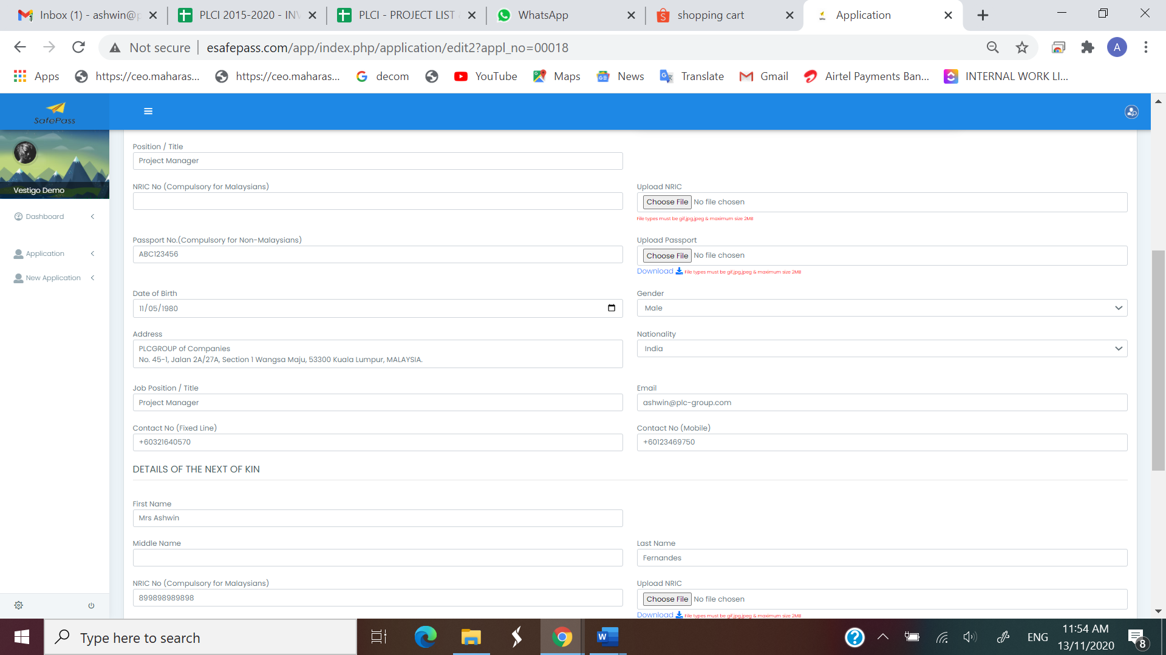



1. Need to put a note at the start of the form (anywhere at the top of the form) – “PLEASE FILL THE FORM IN CAPITAL LETTERS”

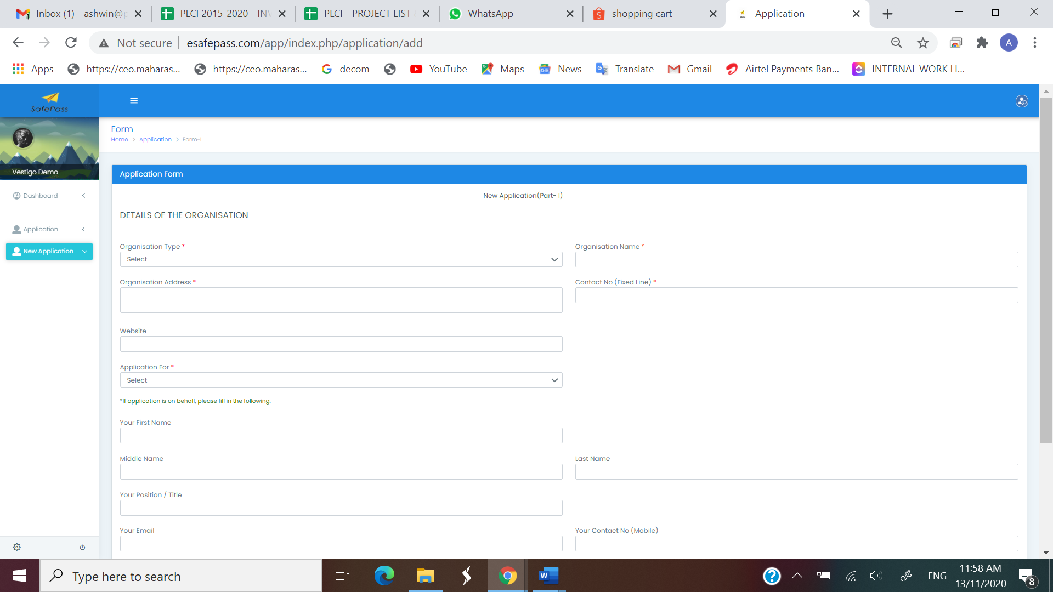



1. Admin unable to view downloads for the application form. It throws an error when the admin tries to download the attachments that are uploaded by the applicant. The error screenshot is as stated below:
2. Also, the admin is unable to download all the attachments (group download for the application form).like for example – download all attachments for the application from to a zip file.

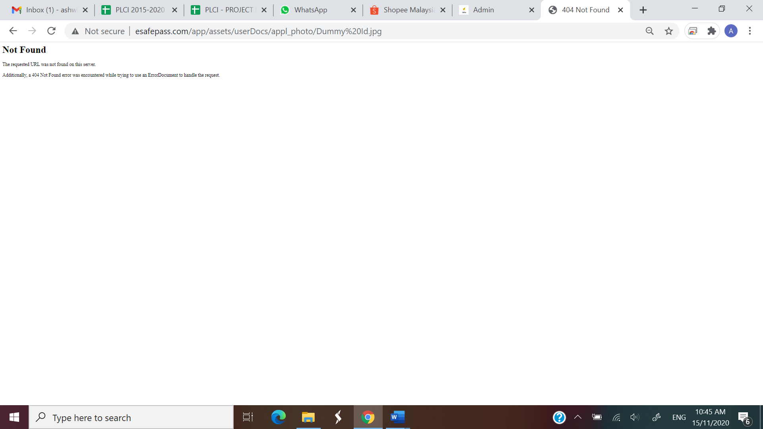

1. The applicant during the process of his / her application uploads several documents (example picture, medical certificate, training certificates etc). The upload format to be as follows:
   * 1. Picture upload – jpg, jpeg, png (all picture formats only)
     2. Other uploads like medical certificate, training certificate etc – jpg, jpeg, png as well as pdf format
2. For all uploads, file size to be 3 mb per file
3. “Allergies” and “if yes please state” field to be made mandatory

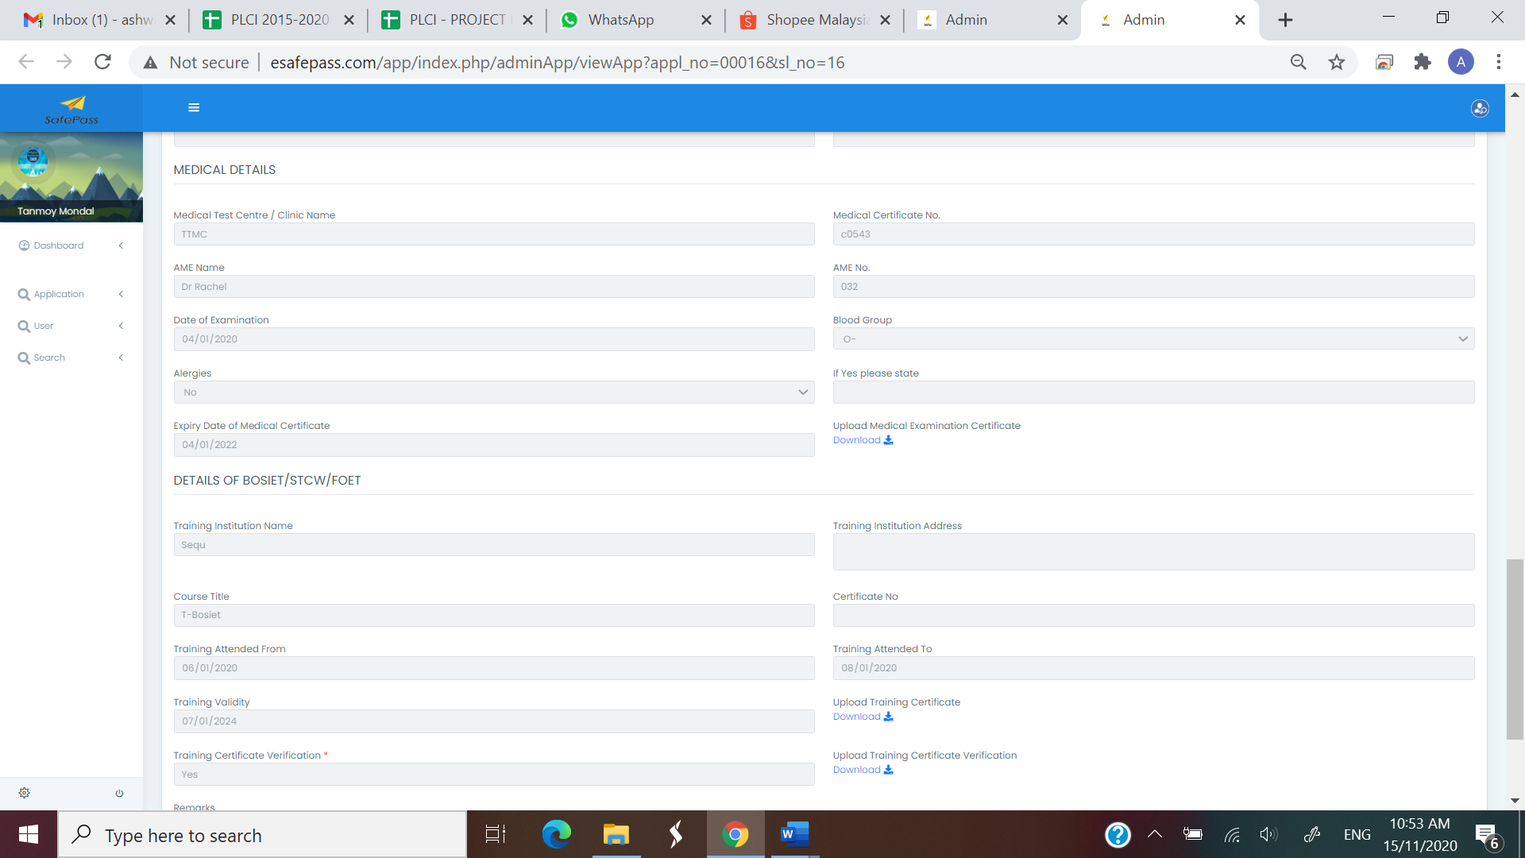



1. In the section “Details of H2S Training, the following fields are not required:

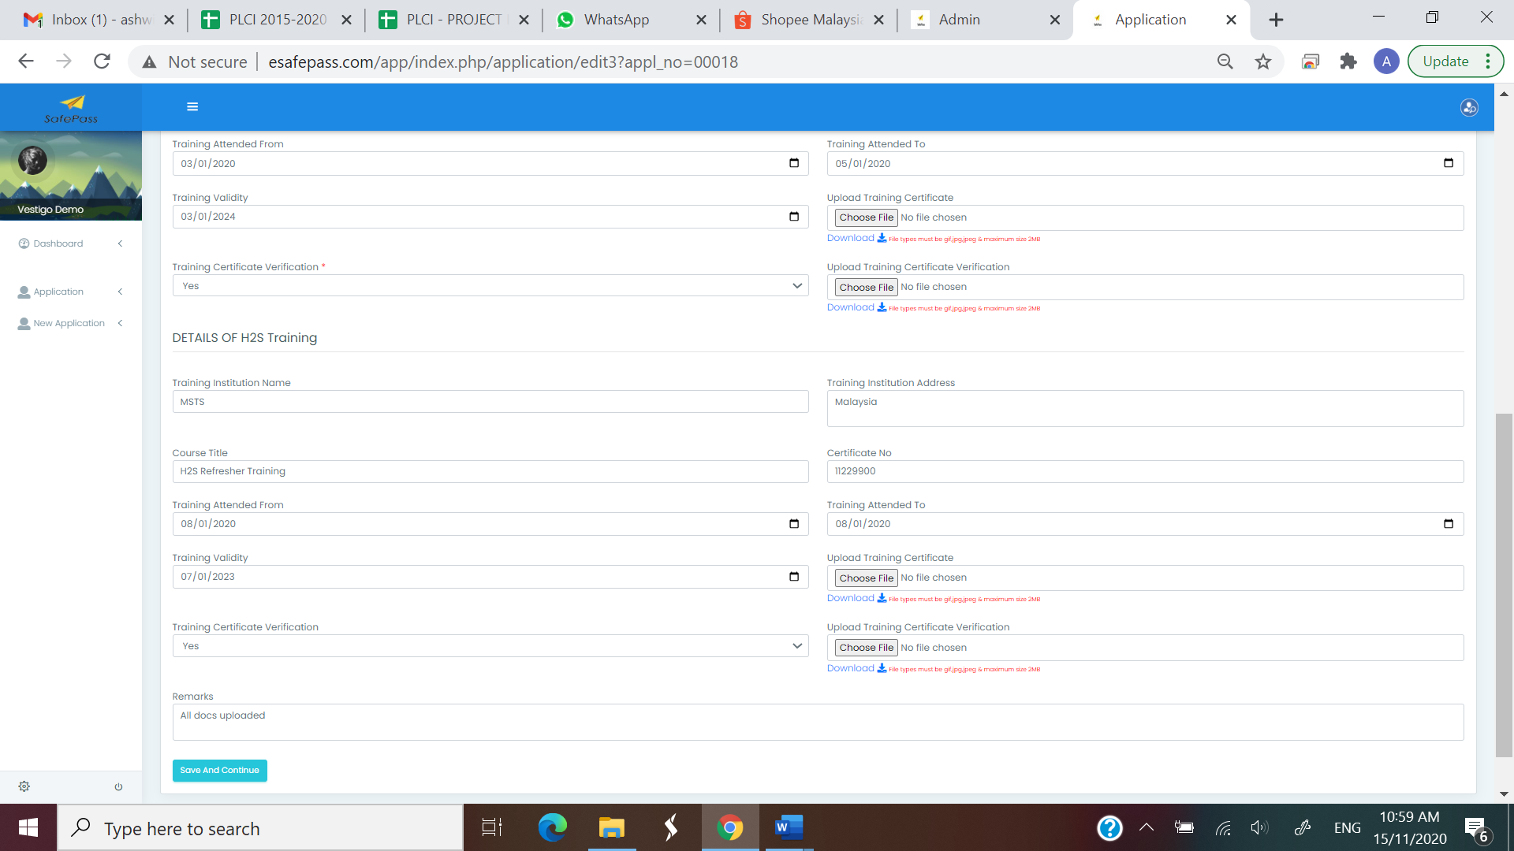



1. The admin is not able to view the complete application form submitted by the applicant. The admin can only view the form until the section “DETAILS OF BOSIET/STCW/FOET”

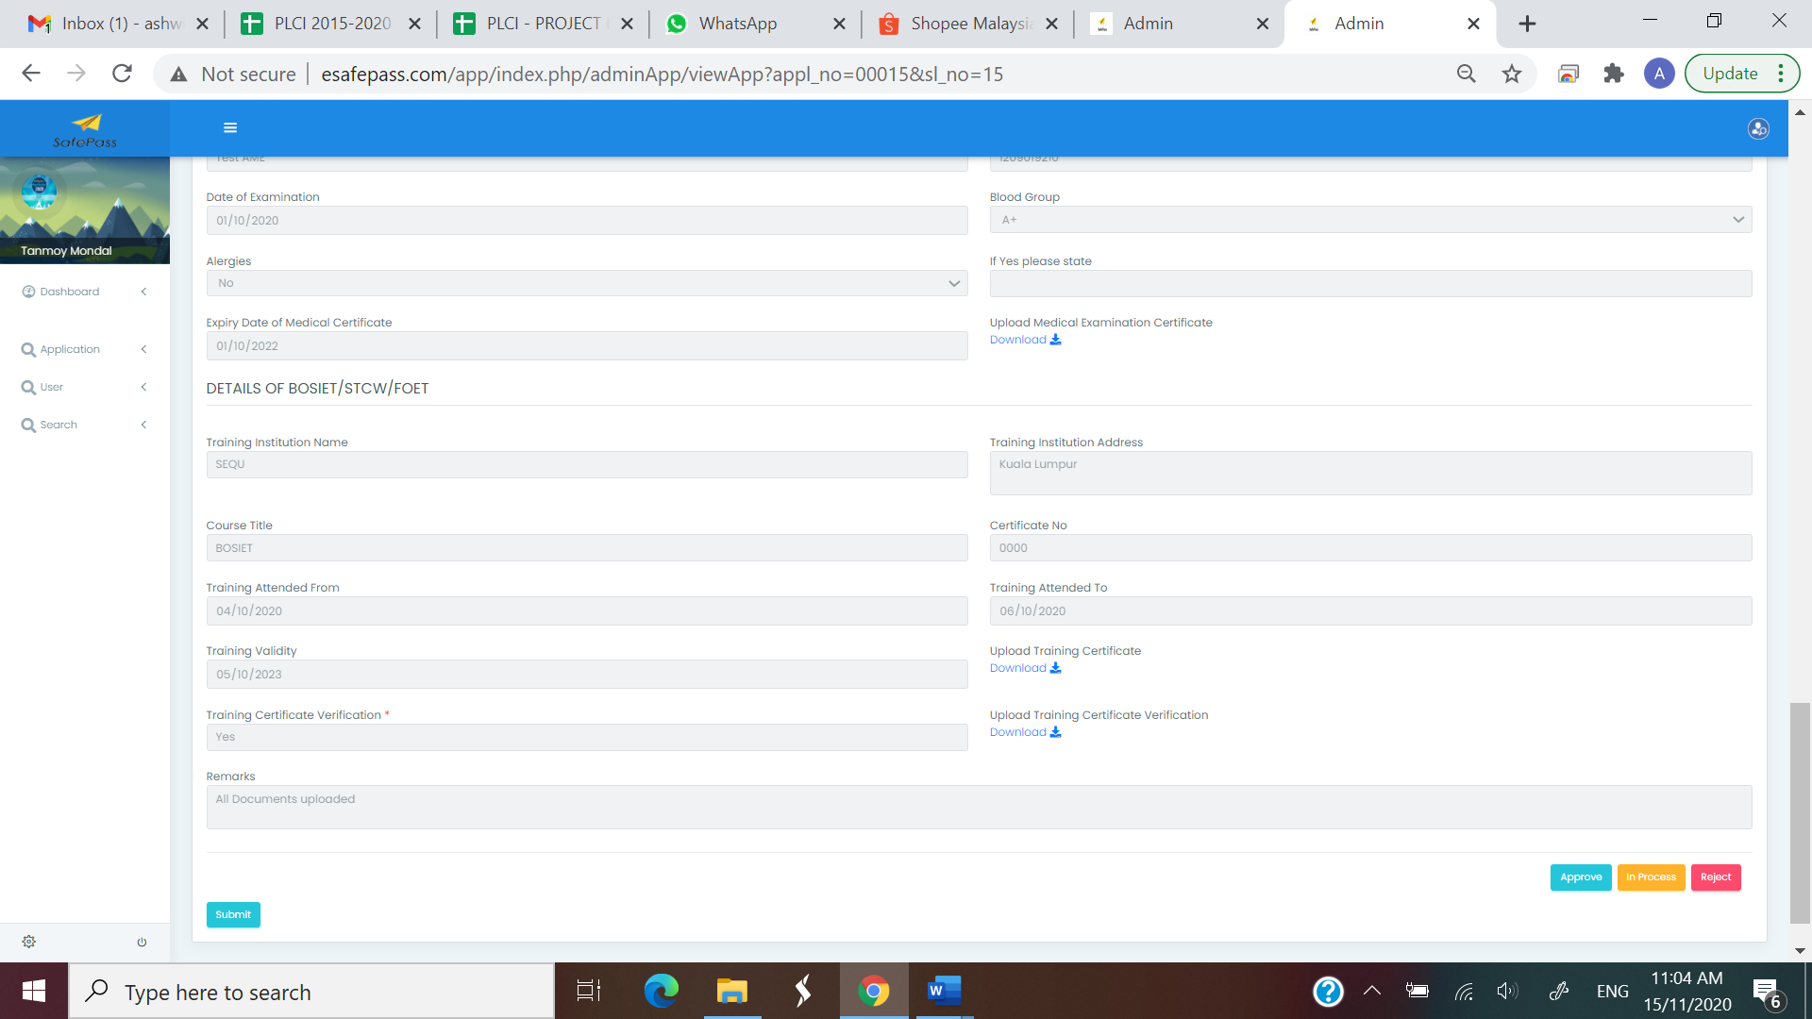

1. The application form needs to include a field for “Date of Application” . The field should be automatically filled in – system should pick the date of the application. ( based on todays date). Maybe right at the top of the application form

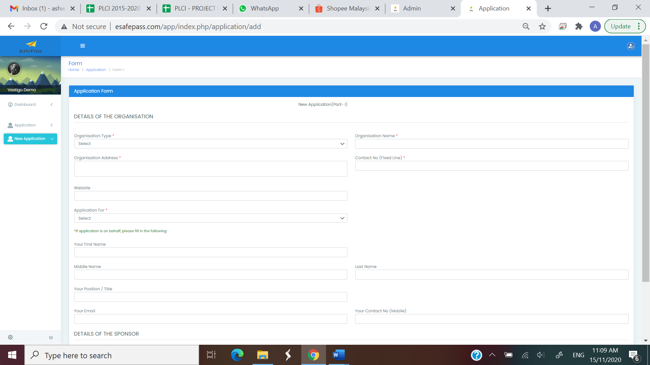

1. Need to include filters / search criteria for applicant, admin as well as super admin profiles.

* Search by date
* Search by First Name
* Search by Last Name
* Search by NRIC Number
* Search by Passport

1. Some fields in the application form needs to have additional instructions. For example:
   * 1. Details of the Sponsor Section.
        1. We need to put a note for the “Sponsor Name Field” - Name of the Person In Charge from Vestigo
        2. “Sponsor Department Field” – The Department of the Person In Charge from Vestigo

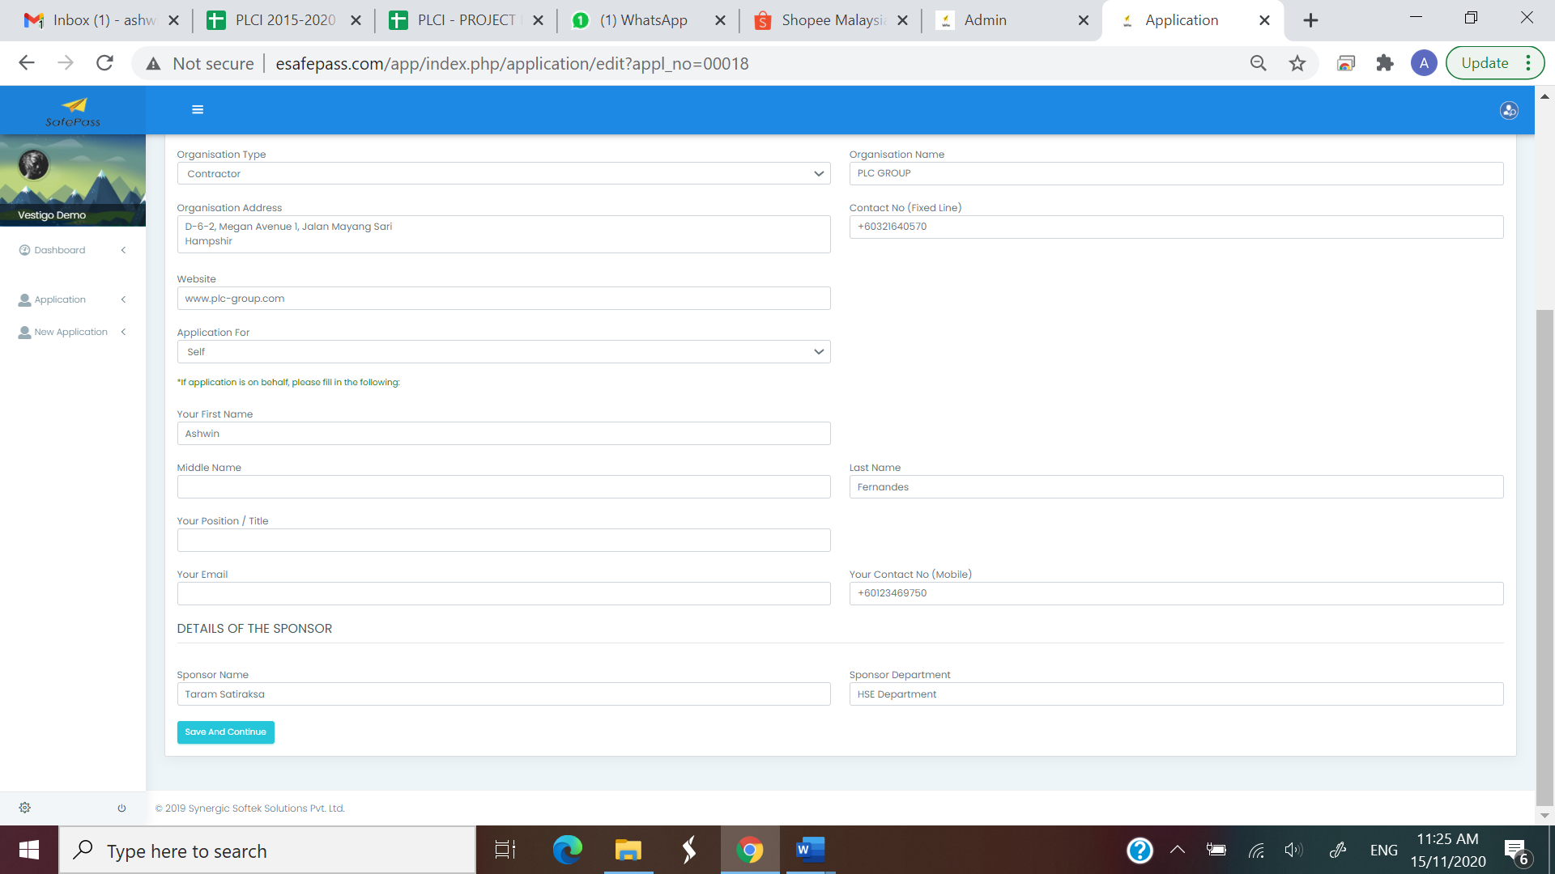



1. In the section “DETAILS OF H2S Training”, we need to put a note stating: H2S is required for Larut, xxx and xxx.

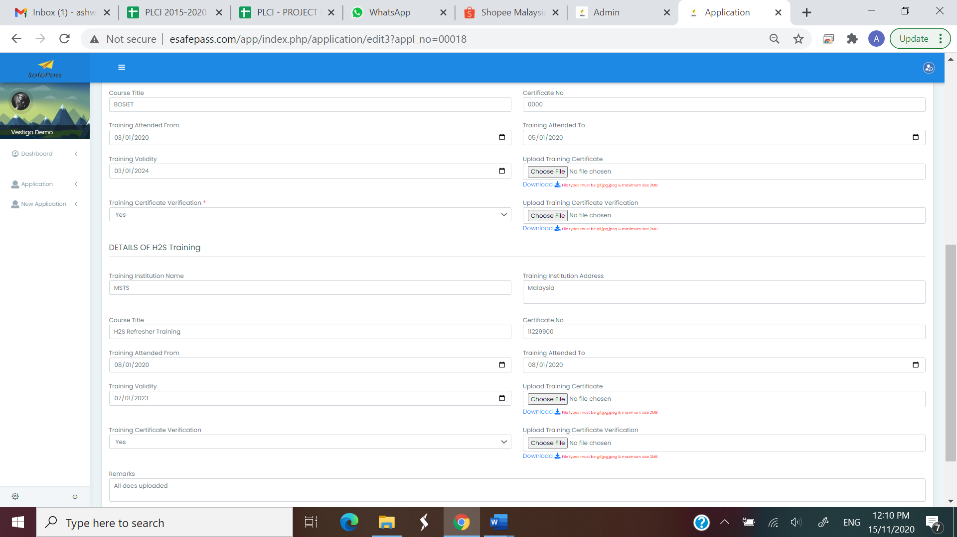



1. At the end of the application form (when the applicant is submitting the application form), we need to add a check box and the following declaration:

Applicant Declaration:

I hereby confirm that the information provided herein is accurate, correct and complete and that the documents submitted along with this application form are genuine. I hereby undertake to provide to Vestigo Petroleum Sdn. Bhd. And / or its representatives with any additional documentation requested in order to support the applicant and its approval as deemed necessary.

This note along with a mandatory check box can be added to the application form before the submit button.

1. There are a few changes to be made on the final Safepass:
2. On scanning the QR code it should reveal the name of the applicant as well as the card validity.
3. QR code to be position below the picture of the applicant
4. Add health declaration at the bottom - I declare that I am of good health and I do not have any physical defect, deformity or disability. I further declare that I perform all my routine activities independently and I do not expect to receive any treatment, nor do I expect to be hospitalized for any ailment or disease. (can be added under vestigo address, the place where the earlier qr code was positioned.)
5. Add Declaration on the applicable permits - I declare and ensure that I have obtained and I am in possession of a valid visa / work permit / other applicable requirements as deemed necessary to carry out work activities in Malaysia and its respective states / federal territories. (can be added under vestigo address, the place where the earlier qr code was positioned.)
6. Since H2S training dates are not required, the card validity will now be based on: one month before the expiry of either BOSIET / HUET or Medical expiry.
7. Details of the applicant included in the safe pass:
   1. Card No :
   2. NRIC No :
   3. Passport No :
   4. Nationality :
   5. Company Name :
   6. Address :
   7. Telephone No :
   8. Position / Title :

***Note: NRIC or Passport (either field that’s filled in by the applicant at the time of the application.***

1. If the expiry of the pass is within 30 days, can admin / super admin get the authority to supersede or extend the pass or some other solution.. looking for advise on solutions.
2. Can there be a feature for back up - Backup in excel, pdf – is it possible for automated daily backups. Also can there be a back up of all the approved safepass (final products) separately.
3. Can admin and super admin download a blank template of the entire safepass application form.. I am thinking of this as either an excel form or a pdf editable. This is for a scenario where the system is down and applicants cannot fill in their application online.. so the admin / super admin can pass this form for them to fill in.
4. Also if this form is filled in (excel for example).. can it be uploaded back to the system?
5. After these changes / additions are made and when there are no more changes / additions to the application, I would like to transfer the entire thing to another website (ill give you the details once I have it). The intention is to have a clean slate for our client. We will still maintain the existing safe pass and the existing website – esafepass.com
6. Need your advice on how to make the site secure.. as people will be adding and uploading confidential data on the site. After the pass is approved, can the attachments be taken off and stored offline.. to reduce the risk of having personal and confidential data online for a long time.
7. I will provide you with some content to be modified / added in the website [www.esafepass.com](http://www.esafepass.com). Also will provide you with the Malaysian Data Protection Policy and its contents to be added to the website [www.esafepass.com](http://www.esafepass.com)
8. At the time of writing this feedback, I am unable to download any safepass, it throws the following error.

